Module 2 **: Installation and Maintenance of Hardware and Its**

**Answers sheet**

* **Section 1: Multiple choice**

1. **B**  [ Electrostatic discharge can damage sensitive computer components like the motherboard, RAM, and CPU.]
2. **C** [ Thermal paste fills in microscopic gaps between the CPU and the heat sink, ensuring better heat transfer.]
3. **A**  [ A digital multimeter is used to measure voltage, current, and resistance.]
4. **A**  [ The CMOS battery powers the CMOS chip, which stores BIOS settings.]
5. **True** [ When installing a new hard drive, formatting is essential to prepare it for storing data.]
6. **False** [ A POST (Power-On Self-Test) error can indicate a problem with various hardware components, not just the CPU.]
7. **False** [ While it may seem safe, removing a USB flash drive without ejecting it can cause data corruption or loss.]
8. Installing a new graphic card in desktop computer following few steps before you start you should shut down computer after that unplug all of the cables from the back of the computer. **step 1**: remove expansion slot plates **step 2**: open your PCLe Slot after **Step 3**: Install the Graphics card **Step 4**: Secure the Graphics Card , to the expansion slot the chassis with screws. **Step 5** Attach your PSU Connectors **Step 6**: final step in this process is that connect your Monitor and boot the pc install or update derivers.
9. First of all we needs tools for disassembly like Phillips-head screwdriver, thermal paste and anti static wrist strap that it. After that our first step is shut down computer and unplug all cables. Remove the side panel of the case using a screwdrier. Remove the old CPU fan you can see

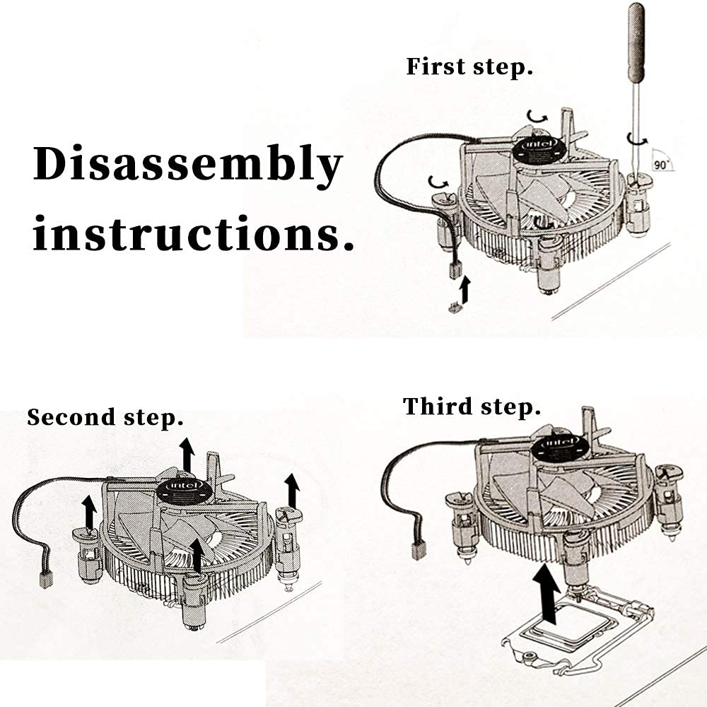

this image in first step how to remove fan from CPU. Unplug the fan cable from the CPU FAN header on the motherboard after that use a screwdriver. You can see in image after remove fan we can unplug that cable and also open that lock which in available in fan. Finally your remove fan you should clean before install new fan. Last but not in the list step is install new CPU fan.

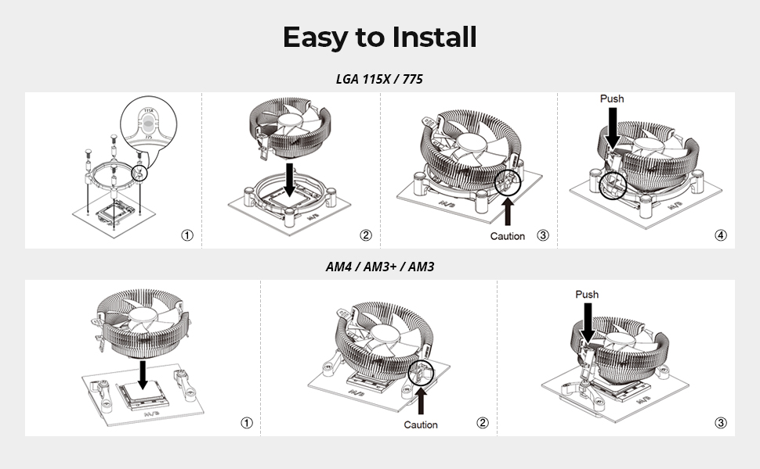

You can see in this image how to install CPU fan before installing make sure the new fan onto the existing heatsink using screws or clips whatever give with fan mostly give a clips by default. Finale step is check all cable and all on position after that reattach the side panel and reconnect power cables. Additionally, power on the computer and press boot key go on bios to chack fan is show or not if not then install.

1. In this generation computer, mobile and leptop and so on most important in human life like now a days education, professional and personal purpose. In those line I say computer is more important also their regular maintenance. Despite regular maintenance of computer hardwear is not just a matter of convenience. It is essential practice that ensures that longevity, efficiency and security of the machine. This essay into the significance of regular hardware maintenance and provides examples essential maintenance tasks [ **Ensuring optimal performance, prolonging hardware lifespan, preventing system failures and data loss and enhancing security** ]

**Prolonging Hardware** **Lifespan :-** Like any mechanical device, computer hardware experiences natural wear with usage. However, neglecting maintenance can accelerate this process. By addressing minor issues promptly, users can extend the lifespan of components such as hard drives, batteries, and cooling systems. Tasks like inspecting cables for wear, replacing degraded thermal paste, and monitoring power supply units help maintain the health of the hardware. This proactive approach reduces the likelihood of costly repairs or replacements, making regular maintenance a financially prudent practice. **Preventing System Failures and Data Loss :-** System failures can be catastrophic, especially when they result in the loss of critical data. Preventive maintenance minimizes the risk of such events by identifying potential problems before they escalate. For example, running diagnostic tools to check disk health can reveal bad sectors that might otherwise lead to hard drive failure. Backing up data regularly to external drives or cloud storage further safeguards against loss, ensuring that valuable information remains intact even in the event of a hardware malfunction. **Enhancing Security** :-In today's interconnected world, cyber threats pose significant risks to computer users. While software-based security measures are crucial, hardware maintenance plays a complementary role. Updating firmware, inspecting hardware for unauthorized modifications, and replacing outdated components enhance the system's resilience against attacks. Neglecting these tasks can leave vulnerabilities that hackers may exploit. Examples of Maintenance Some key tasks are:

* **Cleaning**: Remove dust from fans, vents, and other components to prevent overheating.
* **Updating Software**: Install the latest updates for operating systems, drivers, and applications.
* **Checking Disk Health**: Use tools to identify and rectify errors on hard drives or monitor SSD performance.
* **Backing Up Data**: Regularly save critical files to external or cloud storage solutions.
* **Inspecting Connections**: Check cables and ports for damage or loose connections.
* **Replacing Thermal Paste**: Reapply thermal paste on the CPU to maintain effective heat dissipation.
* **Monitoring Temperatures**: Use software to ensure cooling systems are functioning properly.
* **Battery Maintenance**: Calibrate and avoid overcharging laptop batteries to sustain their capacity.

**In conclusion** regular maintainance of computer is best for computer and also their performance and expending the lifespan.